|  |  |
| --- | --- |
|  | *Shahid Smarak College* |

*Kathmandu, kirtipur – 10*

*Lab Report of OOP in JAVA*

Submitted by: -

Amir Maharjan

BCA 3rd Semester

Submitted to: -

Department of BCA.

Introduction

Java is an object-oriented programming language developed by sun Microsystem of USA in 1991. Java is purely object oriented.

It was originally named ‘Oak’ by James Goslin. (One of the inventers of java.)

Java is compiled into the bytecode and then it is interpreted to machine code.

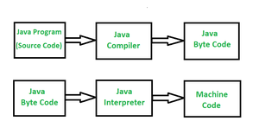

Basic Structure of a Java program

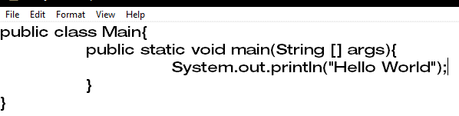

Output



Lab 1

Variables and Data types

Program

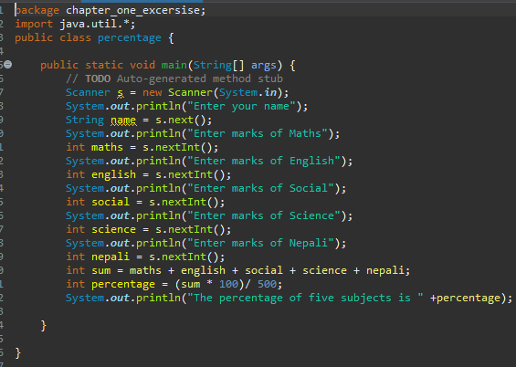

Output

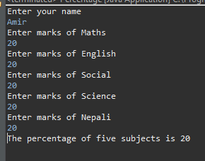

Lab 2

Operators and Expressions

Program

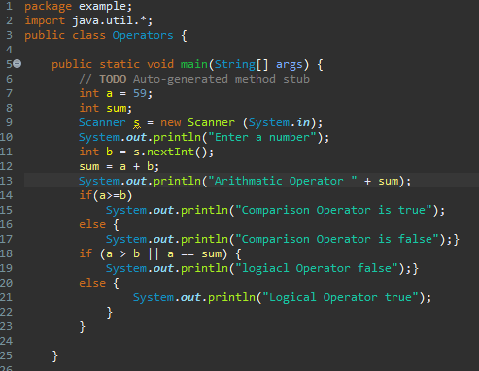

Output

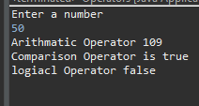

Lab 3

Control Statements

1. Decision Making Statements

Program

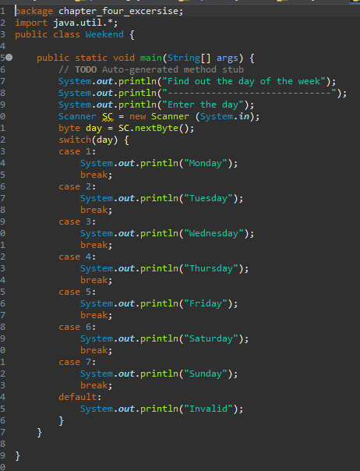

Output

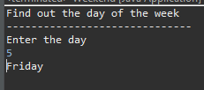

1. Loop Statements

Program

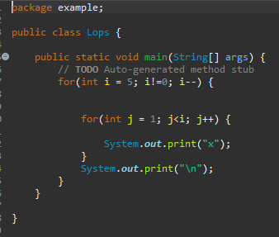

Output



Program

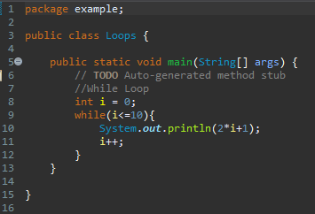

Output

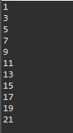

Lab 4

Object Oriented Programming Concepts

Program

A simple class, creating class instances, adding methods to a class, calling function/methods

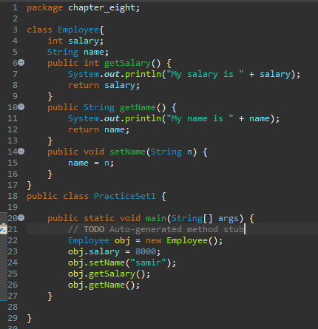

Output



Program

Abstractions

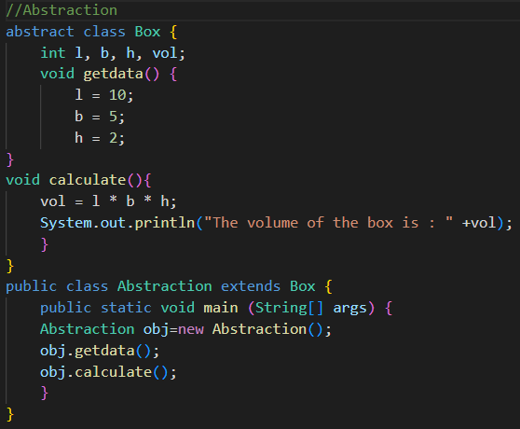

Output

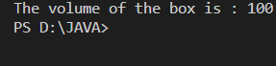

Program

Encapsulations

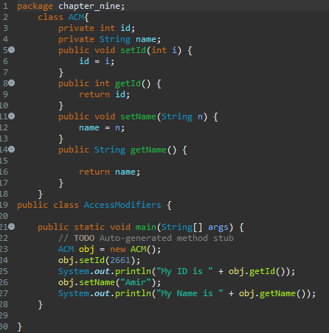

Output

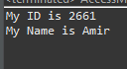

Program

Polymorphism

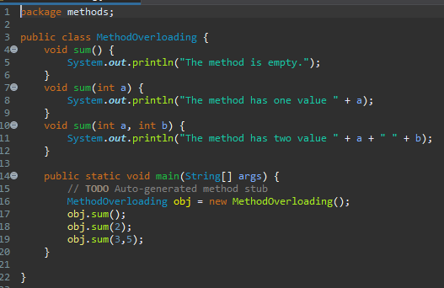

Output



Lab 5

Inheritance, Constructor, super, extends

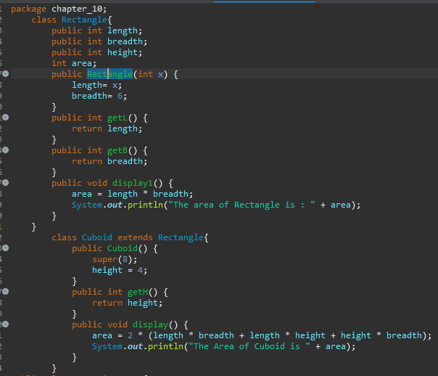

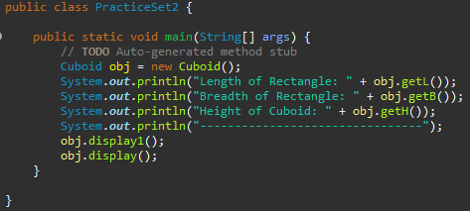

Output

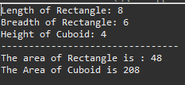

Method Overriding

Program

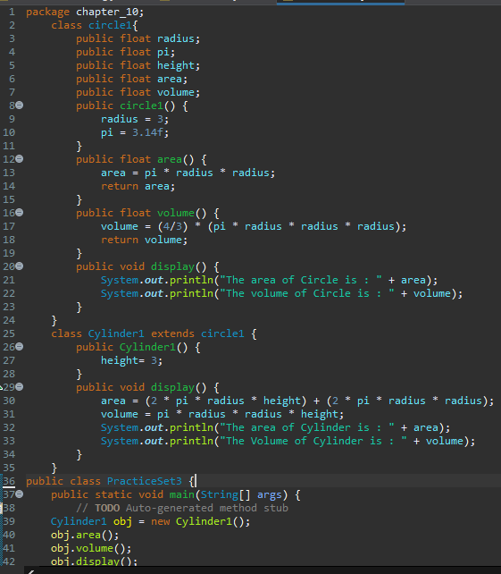

Output



Lab 6

Handling errors / Exceptions

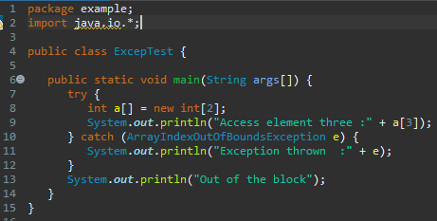

Output



Program

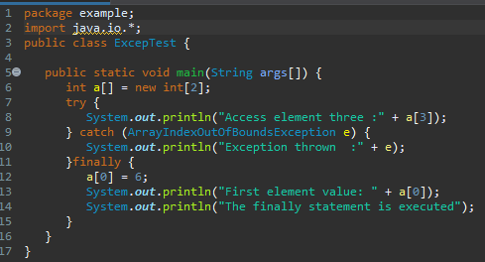

Output



Lab 7

Handling Strings

Program

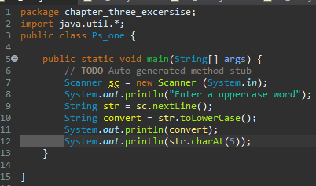

Output

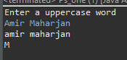

Program

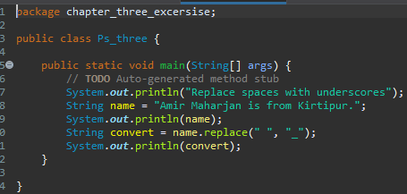

Output



Lab 8

Threads

Programs

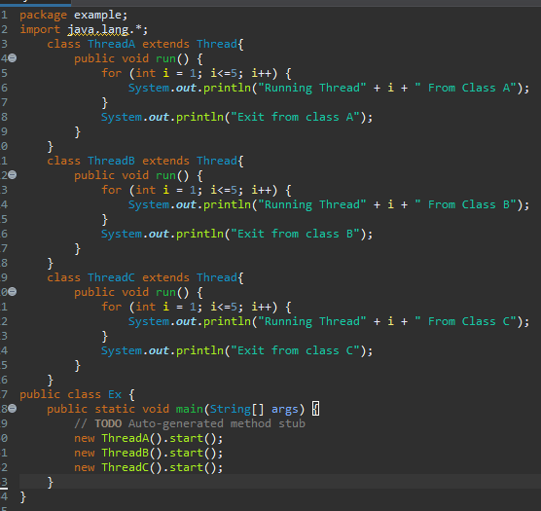

Output

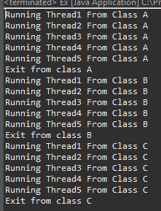

A Game of Rock, paper, scissors

Program

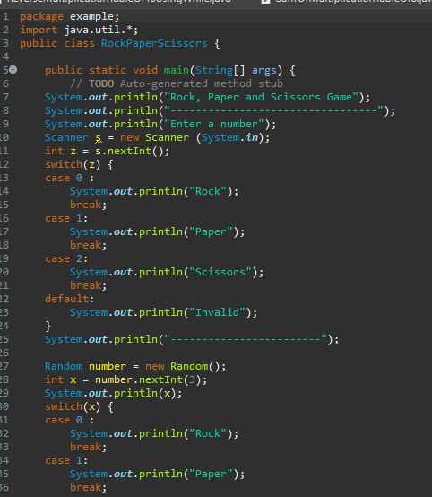

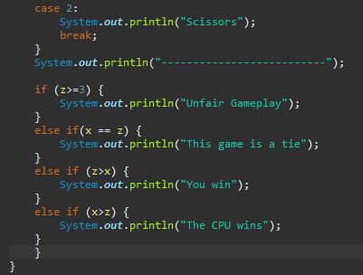

Output.

